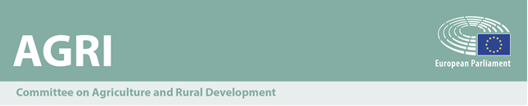

Newsletter
9th legislature - Issue No 28/2020

Committee meeting

Monday 30 November 2020
16.30 – 18.45
Tuesday 1 December 2020
9.00 – 12.00

In visioconference
Brussels, room József Antall 4Q2


**Highlights**

**Study on "The Green Deal and the CAP: policy implications to adapt farming practices and to preserve the EU's natural resources":**

Presentation by Mr Hervé Guyomard (Director of research economics at INRAE),

Mr Jean-Christophe Bureau (Professor of economics at Agro Paris Tech University) and Mr Louis-Georges Soler (Director of research economics at INRAE).



Presentation of the study "The Green Deal and the CAP: policy implications to adapt farming practices and to preserve the EU's natural resources" by the National Research Institute for Agriculture, Food and Environment (INRAE) of France.

This study was requested by the AGRI Committee and commissioned by the Policy Department B. It provides a comprehensive review of the European Green Deal (EGD) initiatives related to agriculture and the food system. It also comprises a set of policy recommendations in order to reinforce the green transition as part of the CAP 2022-2027, in particular with reference to ‘conditionality’ and ‘eco-schemes’ as well as to overall governance.

**Commissioner Janusz Wojciechowski, responsible for Agriculture will present the Commission recommendations to the Member States on the national Strategic Plans**

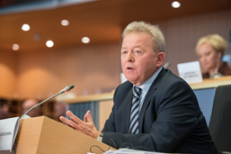

Today, Commissioner Janusz Wojciechowski, responsible for Agriculture, will present the Commission's recommendations to the Member States on the national Strategic Plans. Currently under inter-institutional negotiation, the Strategic plans are the corner stone of the future CAP reform.

**Work in progress**

**Transitionary Measures Regulation - Duration, 2019/0254(COD):**

**Ongoing trilogue negotiations**

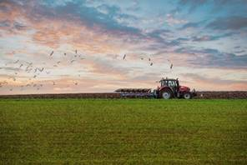

Our rapporteur Ms Katainen (RE, FI) will present the outcome of the fourth trilogue, taking place in a mixed setting on 27 November. Following the partial provisional political agreement reached on 30 June and successful inclusion of the NGEU/ERI provisions agreed under the guidance of Mr. De Castro (S&D, IT), we hope that the rapporteur will return to the Committee with good news.

**Single market: Ongoing trilogue negotiations:**



Our rapporteur, Ms Simone Schmiedtbauer (EPP, AT) will present the outcome of the fourth trilogue which took place on 25 November. The proposed programme brings together activities financed under five predecessor programmes. The AGRI Committee was granted associated status, with exclusive as well as shared competences for parts of the Commission’s proposal, namely on the “Food Chain Programme” part, which relates to the sanitary and phytosanitary programmes as well as to the animal welfare programmes.

**Votes**

**Impacts of EU rules on the free movements of workers and services: intra-EU labour mobility as a tool to match labour market needs and skills**



Members will vote the AGRI opinion to the EMPL INI report on Impact of EU rules on the free movements of workers and services. AGRI MEPs have tabled 101 amendments. The rapporteur, Ruza Tomasic (ECR, HR) has been able to produce 13 compromises, namely focusing on the crucial role of seasonal workers for ensuring food security, the key role played by the technical and higher education in agriculture and the right to fair and equal treatment regarding working conditions, access to social protection and training for workers.

**Establishing an EU Strategy for Sustainable Tourism**



On 1 December, AGRI will vote on MEP Marlene Mortler (PPE, DE) opinion on establishing an EU strategy for sustainable tourism. Through this vote, the Committee should underline the positive economic contribution of rural tourism and its role in safeguarding small-scale and diverse farming. Members should also stress the synergies between rural tourism, environmental protection and European cultural heritage and customs. The opinion also calls on the European Commission and the Member States for appropriate financing and for the development of an effective and comprehensive strategy in the rural tourism sector.

**Reversing demographic trends in EU regions using cohesion policy instruments**



Members will vote on the AGRI opinion to the REGI INI report Reversing demographic trends in EU regions using cohesion policy instruments. AGRI MEPs have tabled 74 amendments. The rapporteur, Mazaly Aguilar (ECR, ES) has been able to produce 6 compromises, namely focusing on the demographic challenges in EU policies, the creation of new economic opportunities in rural areas, the role played by EU Strategies F2F and Biodiversity and the importance of innovation, education and training.

**New Circular Economy Action Plan**



Members will vote on the AGRI opinion to ENVI INI report A New Circular Economy Action Plan. AGRI MEPs have tabled 102 amendments. The rapporteur, Claude Gruffart (Greens/ALE, FR) has been able to produce 13 compromises. The opinion welcomes the Commission's communication, since it fully reflects the changes required for an evolving economy to meet the needs of sustainable development, making it possible to create jobs while protecting the climate, the environment and biodiversity.